**Week 1 Task Completion Report**

**Project Title: Sustainable Supply Chain Performance Dashboard in Power BI**

**Mentoring Session: Week 1**

## Topics Covered and Practical Activities

### Practical Activities on Microsoft Power BI Desktop:

**1. Opening a Blank Report**

- Opened a blank report in Power BI Desktop.

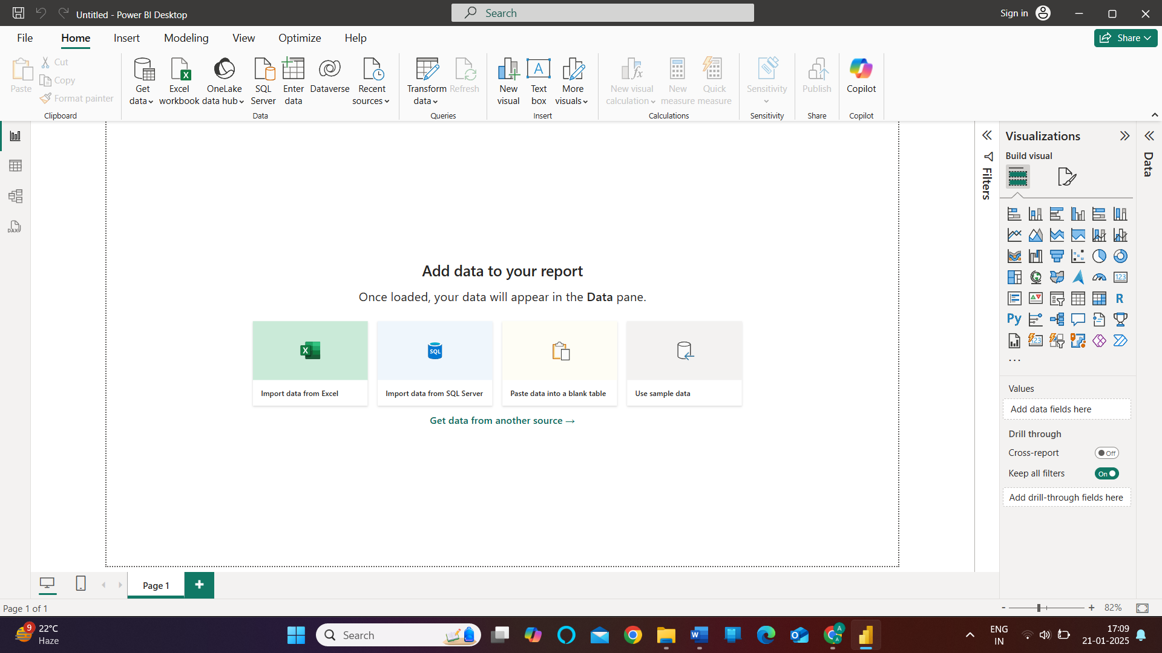

**2. Importing Data**

- Used the 'Get Data' option from the HOME tab.

- Selected 'Text/CSV' option to extract data from the system.

- Observed the two options after importing data:

- LOAD: Used when the data is cleaned and ready.

- Transform Data: Selected when the data requires cleaning or error correction.  
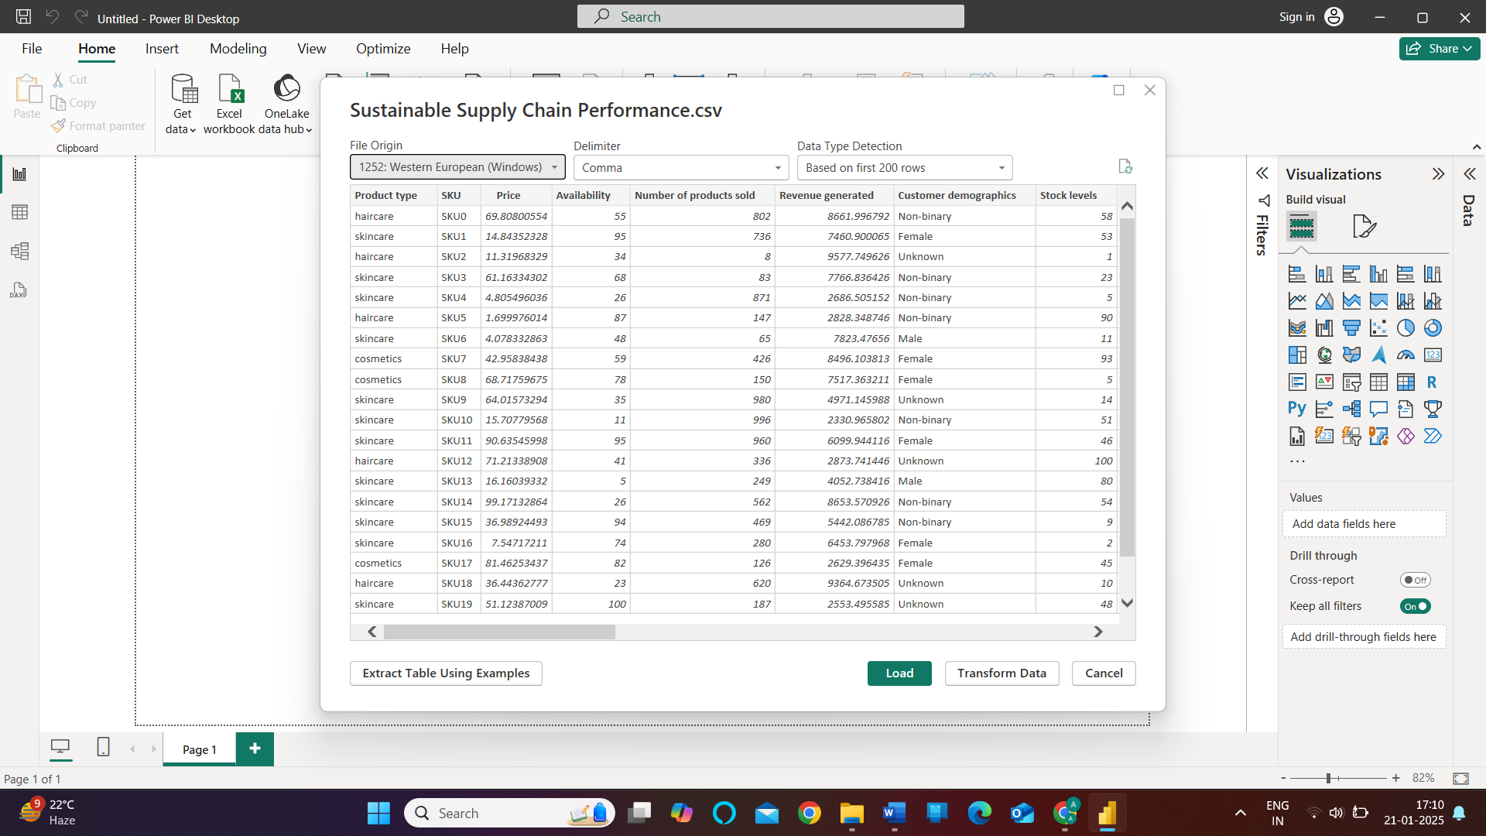

**3. Data Transformation in Power Query Editor**

* Accessed Power Query Editor by clicking on the 'Transform Data' option in the HOME tab.

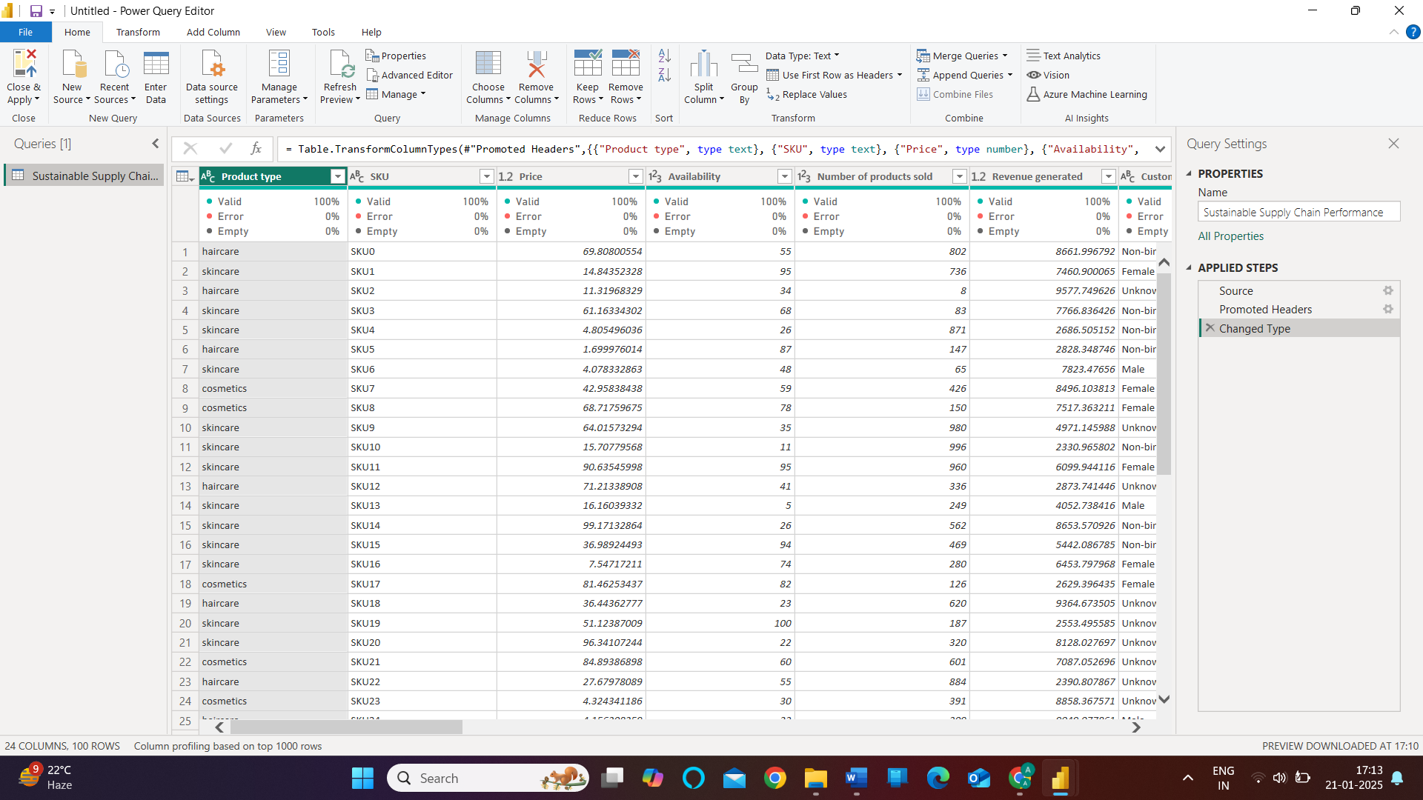

* Performed the following transformations:
* Duplicated the 'Sustainable Supply Chain Performance' table.
* Created separate tables for: Inventory, Manufacturing, Supplier, Supply Chain.

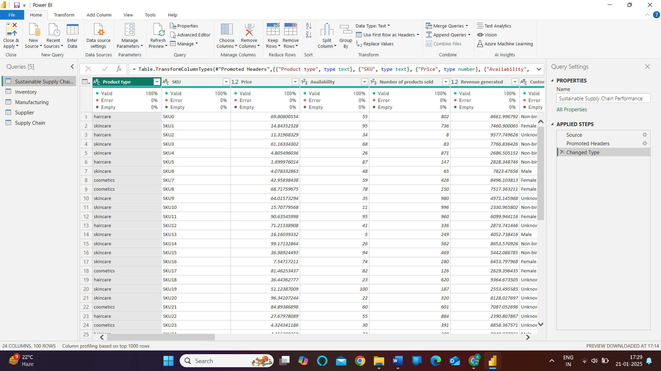

* Clicked on 'Close & Apply' to reflect these transformations in the main Power BI Desktop workspace.

## Theoretical Topics Covered:

### About the Project

The project involves analyzing all business supply chain-related data, including: Product types, SKUs, prices, availability, Sales, revenue, customer demographics, Stock levels, lead times, shipping details, Supplier information, production, volumes, defect rates, transportation modes.

The primary goal is to analyze supply chain performance and identify key metrics such as:

* Total revenue
* Average manufacturing costs
* Total products sold
* Most selling products
* Defect rates
* Shipping costs
* The analysis will be visualized through a comprehensive Power BI Dashboard with three pages:
* Revenue Analysis
* Supply Chain Performance
* Defect Rates

### Learning Objectives:

By the end of this project, the following skills and knowledge will be developed:

1. Understanding the basics of data analytics and Power BI.

2. Application of data analytics concepts in the case study of Sustainable Supply Chain Performance, including:

* Total Revenue Generated by Product Type.
* Average Defect Rates by Product Type.
* Total Revenue Generated by SKU.
* Revenue Generated by Suppliers.
* Revenue Generated by Carriers.
* Percentage of Sales by Product Type.
* Total Products Sold by Shipping Carriers.
* Percentage of Total Price by Transportation.

### BI Tools Used:

- Power BI (Microsoft)

### ETL (Extract, Transform, Load)

1. Extract: Pull data from sources such as Excel, CSV, text files, or database files.

2. Transform: Clean and process the data.

3. Load: Analyze the data after cleaning.

### Analysis Insights

Visualizations provide facts and insights through dashboards.

Different views in Power BI:

* Report View: For visualization.
* Table View: To view raw data.
* Model View: To establish relationships among data.

Submitted By: [ABHISHEK PAL]

Week: 1